

Word Replacement Interview

Report

30/12/2022

# **Introduction**

In this project, we have developed a python API that allows a user to enter a text, and the application will search for keywords and replace them with suitable words. The API was built using FastAPI.

## Flow Chart

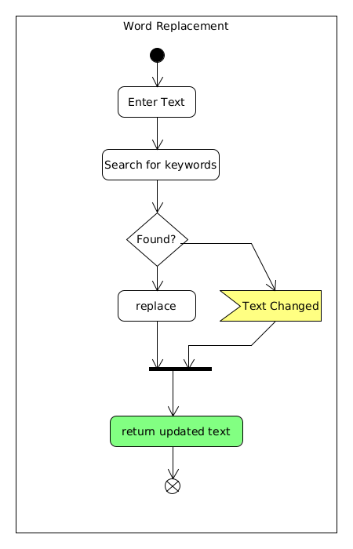

A user enters the search text, the application searches for word occurrences and then replace them with their respective replacements. If there are no replacements the exact text is returned.

The docker image can be built using

$:> *docker build -t word-replacement-api .*

Then the following command can be used to run the image

$:> *docker run -p 8000:8000 word-replacement-api*

In order to access the API documentation in Swagger open API standard and test, access the following address on the web browser

<http://172.17.0.1:8000>